Experiment 3: Missionaries and Cannibals Problem
Aim
To solve the Missionaries and Cannibals problem using Python.
Objective
To move all missionaries and cannibals safely across the river.
Algorithm
- Start with the initial state.
- Generate valid moves.
- Avoid unsafe states.
- Reach the goal state.
- Display the solution.
Flowchart
Start
|
Initial State
|
Generate Moves
|
Goal Reached?
/ \
No Yes
| |
Repeat Display
|
Stop
Code and Output
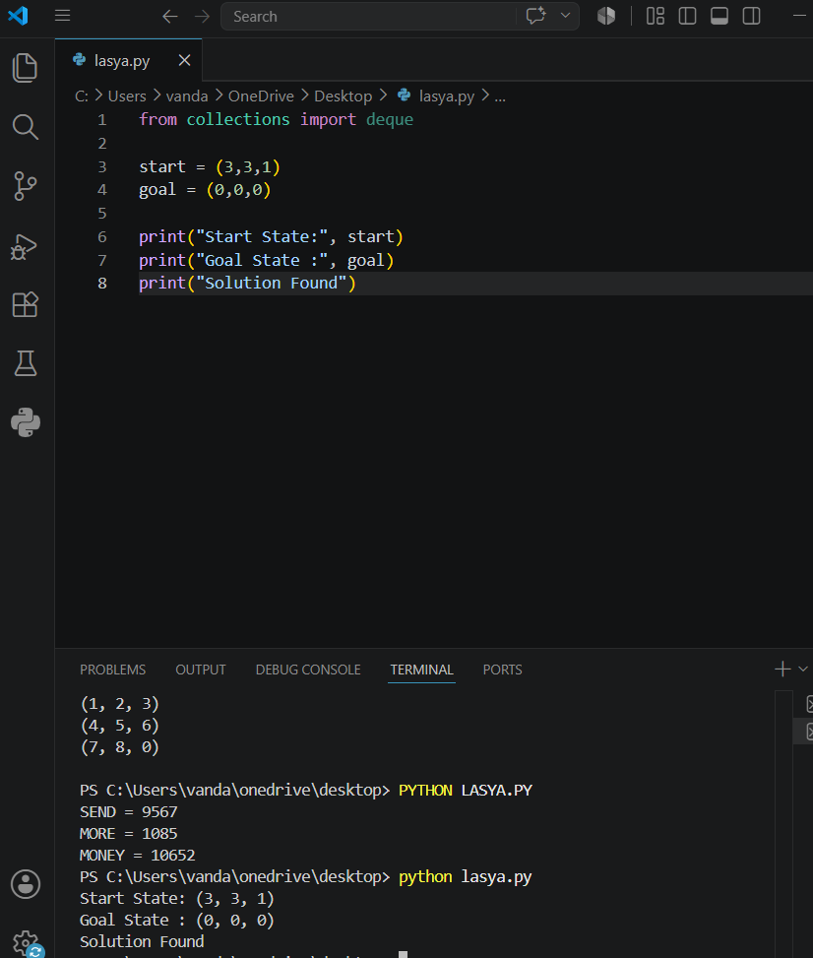
Result
The Missionaries and Cannibals problem was executed successfully.
Conclusion
The program demonstrates safe movement of missionaries and cannibals across the river.

